ASSIGNMENT 11.1

Olympic_data Analysis :

1. Write a Hive program to find the number of medals won by each country in swimming.

STEP 1 : CREATE A TABLE FOR DATA AND ASSIGN CERTAIN DATATYPES REQUIRED



STEP 2: LOAD THE DATA INTO THE TABLE “ OLY”



STEP 3:USE SELECT TO FIND NO.OF MEDALS WON BY EACH COUNTRY IN SWIMMING



STEP 4: OUTPUT REQUIRED

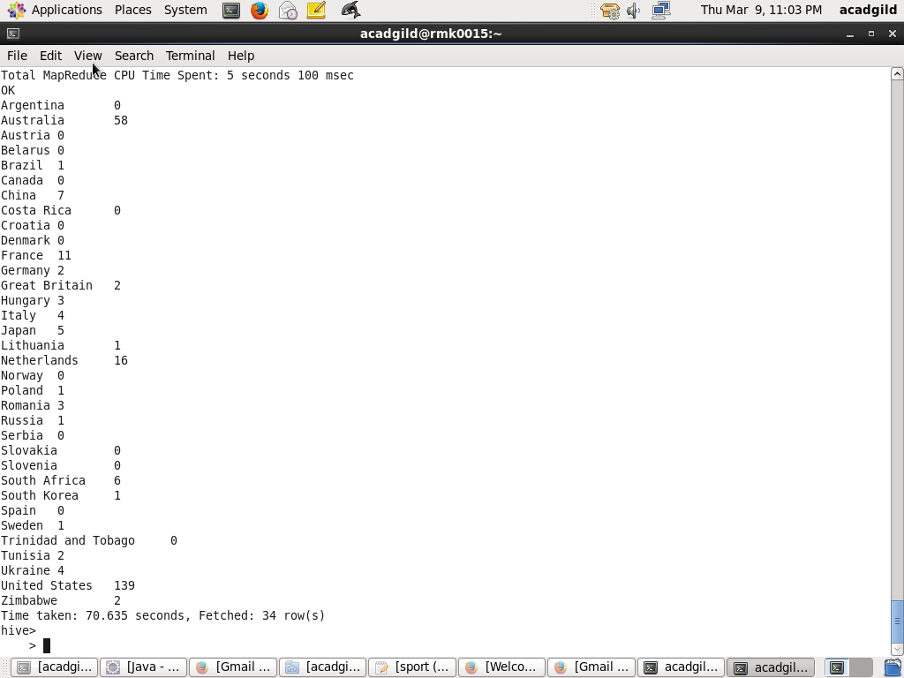

2) Write a Hive program to find the number of medals that India won year wise.

STEP 1: LOAD THE DETAILS INTO TABLE OLY

STEP 2: USE SELECT TO PRINT MEDALS TAT INDIA WON YEARWISE

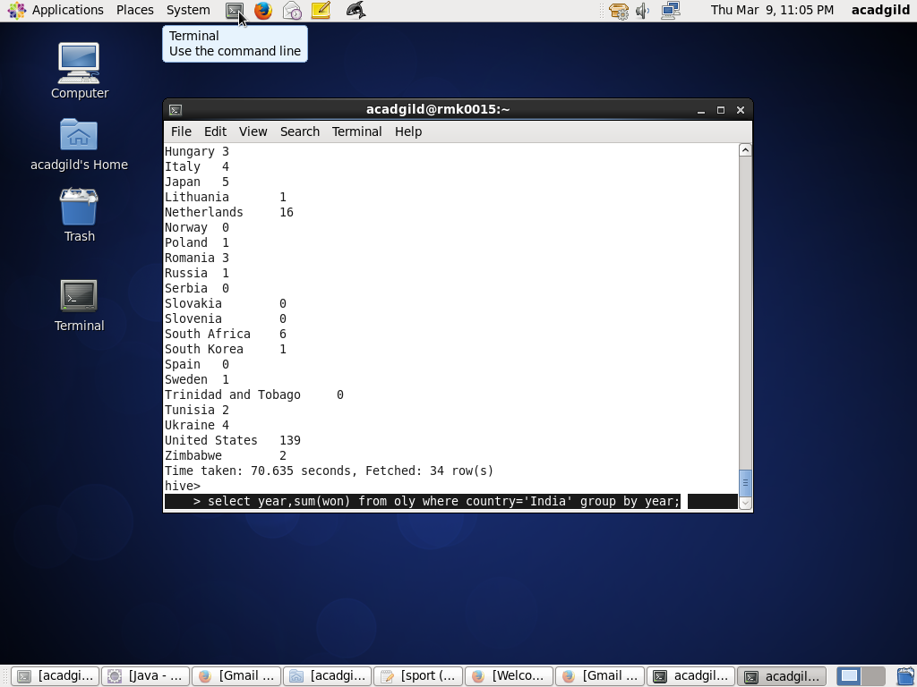

STEP 3: REQUIRED OUTPUT

